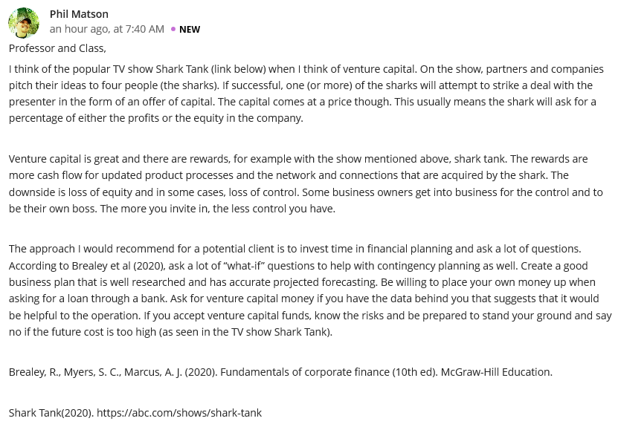
Reply
Actually, investors are supposed to be more vigilant before they invest their surplus capital, more importantly, by knowing the return value as the way you have vividly showcased. Your research has brought light to the business world by pinpointing finer details connected to venture capital as an approach to finance your venture. The potential benefits that am also strongly considering in line with your argument are sufficient cashflows to develop product processes, and not to mention good connections and networking in regards to powerful exchange of ideas and expertise necessary for business growth. However, the investors should be aware to lose equity and control when they request financial support from venture capilists. In addition, to achieve success in your business requires a robust financial plan that focuses on the effective capital funding, explains the risks involved as well as forecasting accurate projections.

Reply
A source of business funding has become a greater concern in the business world enabling investors to make smart choices before selecting a certain source. Sincerely, you are right of venture capital, more specifically, the way it boosts the investor’s capability to finance business regardless of his/her own money. Typically, if you want to attract venture capitalist then you need to have a vital business plan that will significantly tap potential gains. As much as venture capital always rings in the mind of business owners, they should be aware to lose control over their business operations including a possibility of being sued when they are not performing as per the stated objective the way you have nailed it. In this case, I also recommend bank loan although has stringent qualifications but it gives you room to have control over your business and making informative decisions as compared to venture capital. Your study is fundamental to investors because it allows them to decide on the best source of funding based on their financial capacities.

